Q6)Ansible

1)Created the role Skeleton

2)Created Template file

3)Created a playbook to use the Role

4)created Inventory file

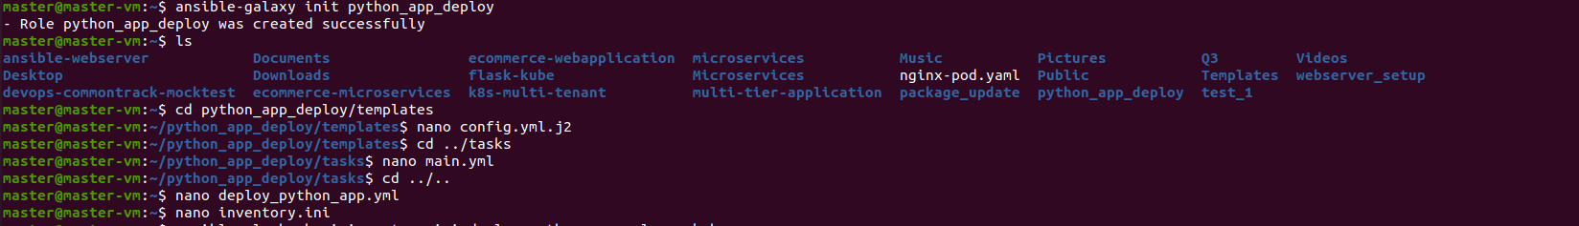

5)Created inventory.ini file

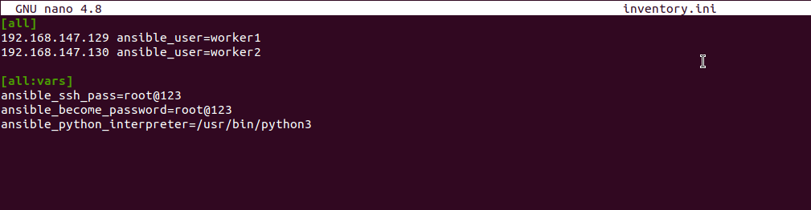

6)Run the Playbook

